**1631099850(1)**

**2021年西农-科迪华 作物绿色生产论坛**

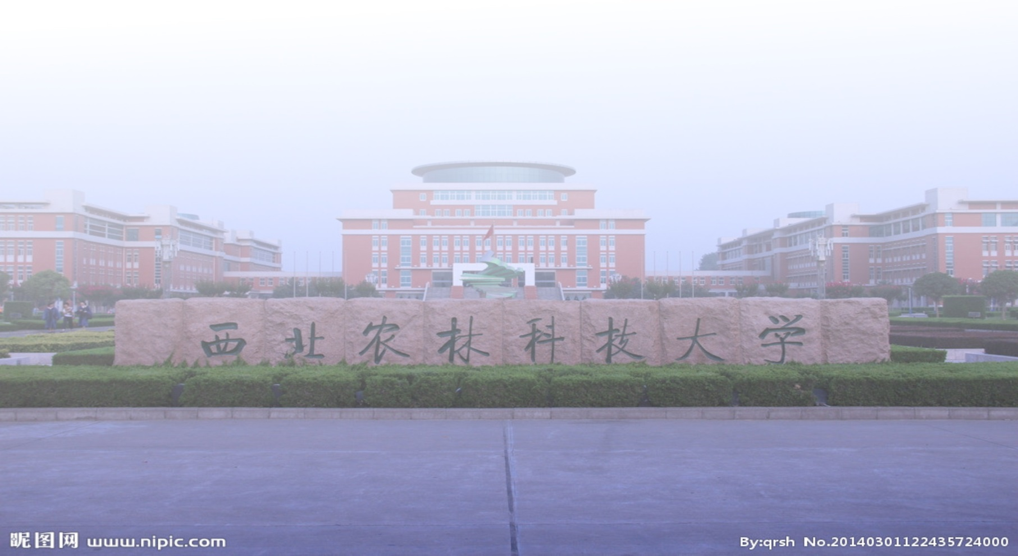

会议手册



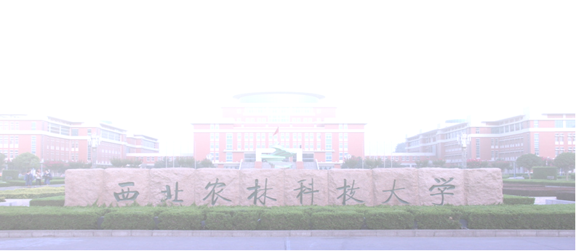****

西北农林科技大学农学院

二O二一年九月十七日

陕西·杨凌

“西农—科迪华”作物绿色生产论坛日程

The Schedule for NWAFU-Corteva Crops Green Production Forum

**主旨：**为了进一步拓展学生国际视野，提升我校作物学科人才培养质量和学科国际影响力，以及更好的培养下一代作物遗传育种接班人，西北农林科技大学与国际知名种企科迪华围绕小麦、玉米、油菜、马铃薯等4个粮油作物绿色生产前沿理论与技术展开深入讨论，为学生了解种业前沿理论技术搭建了一个高水平交流平台，对支撑国家农业可持续发展，尤其是种业的高质量发展起到了积极的推动作用。

**Theme:** In order to further expand students' international vision, promote the quality of talent cultivation and international influence in crop Science of Northwest A&F University and better cultivate the successors for crop breeding, NWAFU-Corteva crops green production workshop will be held around the frontier theories and technologies in green production of wheat, corn, rape and potato. This event will set up a high-level communicating platform for students to understand the cutting-edge theories and technologies of seed industry, and will play a positive role in promoting agricultural sustainable development, especially the high-quality development of seed industry.

**论坛时间：**2021年9月17日，上午8:00-12:15；下午14:00-18:35

**Date：**Morning 8:00-12:15; Afternoon 14:00-18:35

**论坛地点：**西北农林科技大学国际交流中心A104

**Venue：**Meeting room No. A104, International Exchange Center, NWAFU

|  |  |  |  |
| --- | --- | --- | --- |
| 9月17日上午  Morning, September 17 | | | |
| 论坛开幕式  The opening ceremony  主持人：莫非教授  Chairman: Prof. Mo Fei, College of Agronomy, Northwest A&F University | | | |
|
|
|
| 8:00-8:10 | 农学院院长单卫星教授致辞  Welcome by Prof. Shan Weixing, Dean of College of Agronomy | | |
| 8:10-8:20 | 科迪华农业科技公司 Bill Wilson博士致辞  Welcome by Dr. Bill Wilson, Corteva | | |
| 8:20-8:40 | 合影留念 | | |
| Topic 1 | 抗逆育种与绿色生产  （Resistance breeding and green production） | | |
| 主持人：莫非教授  Chairman: Prof. Mo Fei, College of Agronomy, Northwest A&F University | | 报告题目  (Topic of Presentation) |
| 8:40-9:10 | 吉万全教授  （西北农林科技大学农学院）  Prof. Ji Wanquan, College of Agronomy, Northwest A&F University | | 小麦-十倍体长穗偃麦草远缘杂交  研究进展  Progress on wide-cross of wheat - Thinopyrum ponticum |
| 9:10-9:40 | Dr. Charlie Messina, Corteva | | Drought breeding/physiology |
| 9:40-10:10 | 王 东教授  （西北农林科技大学农学院）  Prof. Wang Dong, College of Agronomy, Northwest A&F University | | 按需补灌水肥一体化调节冬小麦实现高产高效的生理生态基础及其应用  The Physiological and Ecological Basis and Application of On-demand irrigation and water-fertilizer integration to Adjust Winter Wheat to Realize High Yield and High Efficiency |
| 10:10-10:30 | 赵天永教授  （西北农林科技大学生命科学学院）  Prof. Zhao Tianyong, College of Life Sciences, Northwest A&F University | | 通过调控糖代谢提高玉米耐逆和种子耐储能力  Increasing the maize plant abiotic stress tolerance and seed storability through regulation of sugar metabolism |
| 10:30-10:50 | 杨 琴教授  （西北农林科技大学农学院）  Prof. Yang Qin, College of Agronomy, Northwest A&F University | | 玉米抗病基因的发掘与利用  Dissection and adoption of disease resistance gene in maize |
| 10:50-11:10 | 李学军教授  （西北农林科技大学农学院）  Prof. Li Xuejun, College of Agronomy, Northwest A&F University | | 小麦HMW-GS及品质功能育种研究进展  Advance on wheat HMW-GS and quality & functional breeding |
| 11:10-11:30 | 茶歇 Tea & Coffee | | |
| 主持人：庞津雯（硕士生）  Chairman: Postgraduate Pang Jinwen, College of Agronomy, Northwest A&F University | | | |
| 11:30-11:45 | 吴鹏（博士生）  Doctoral student Wu Pen, College of Agronomy, Northwest A&F University | | 寄主高尔基体相关的致病疫霉菌RXLR效应蛋白E38毒性功能研究  Investigating the virulence function of the host plant Golgi-associated RXLR effector E38 of Phytophthora infestans |
| 11:45-12:00 | 张燕（博士生）  Doctoral student Zhang Yan, College of Agronomy, Northwest A&F University | | BnBBX22基因正调控甘蓝型油菜的耐盐性  The B-box protein BnBBX22 positively mediates salt tolerance in *Brassica napus* L. |
| 12:00-12:15 | 强琴琴（博士生）  Doctoral student Jiang Qinqin, College of Agronomy, Northwest A&F University | | 观赏向日葵不同花色形成机理研究  Transcriptome sequencing and metabolite analysis reveal the formation of different colored ornamental sunflowers caused by flavonoids flow switch |
| 12:15-14:00 | 午餐 (Lunch) | | 地点：培训餐厅 Venue: Training restaurant |
| 9月17日下午  Afternoon, September 17 | | | |
| Topic 2 | 种质资源发掘与生物技术  (Innovation of Germplasm resources and Biotechnology) | | |
| 主持人：高欣副教授  Chairman: Associate Prof. Gao Xin, College of Agronomy, Northwest A&F University | | 报告题目  (Topic of Presentation) |
| 14:00-14:30 | 单卫星教授  （西北农林科技大学农学院）  Prof. Shan Weixing, College of Agronomy, Northwest A&F University | | 植物易感性分析为提高作物抗病能力提供了新的基因资源 Dissection of plant susceptibility provides novel gene resources for improving crop disease resistance |
| 14:30-15:00 | 宋卫宁教授  （西北农林科技大学农学院）  Prof. Song Weining, College of Agronomy, Northwest A&F University | | 野性与文明的召唤——寻踪小麦和大麦的祖先  Going wild for cereals-tracing the ancestors of wheat and barley |
| 15:00-15:30 | 薛吉全教授  （西北农林科技大学农学院）  Prof. Xue Jiquan, College of Agronomy, Northwest A&F University | | 中国玉米产业发展动态  The latest developments of corn industry in China |
| 15:30-15:50 | 鲁清林研究员  （甘肃省农业科学院）  Prof. Lu Qinglin, Gansu Academy of Agricultural Sciences | | 抗条锈兼抗多种病害兰天系列冬小麦种质创新与新品种选育 Germplasm Resources Creation and New Cultivars Breeding of Lantian-series Winter Wheat Resistant to Yellow Rust and the Other Diseases |
| 15:50-16:10 | 王延鹏研究员  （中国科学院遗传发育研究所）  Prof. Wang Yanpeng, Institute of Genetics and Developmental Biology, Chinese Academy of Science | | 精准基因组编辑以及在作物改良中的应用  The Precise Genome Editing and Applications in Crop Improvement |
| 16:10-16:30 | 陈时盛研究员  （北京大学现代农学院）  Prof. Chen Shisheng, Institute of Advanced Agricultural Science, Peking University | | 小麦秆锈病抗性基因克隆的  研究进展  Research advances in cloning of wheat stem rust resistance genes |
| 16:30-16:50 | 郭东伟副研究员  （西北农林科技大学农学院）  Associate Prof. Guo Dongwei, College of Agronomy, Northwest A&F University | | 玉米淀粉的遗传改良与商业化应用  Genetic improvement and commercial application of maize starch |
| 16:50-17:10 | 茶歇 Tea & Coffee | | |
| 主持人：李玹（硕士生）  Chairman: Postgraduate Li Xuan, College of Agronomy, Northwest A&F University | | | |
| 17:10-17:25 | 杨佳鹏（硕士生）  Postgraduate Yang Jiapeng, College of Agronomy, Northwest A&F University | 寄生疫霉菌效应基因PpE47的鉴定与功能研究  Identification and preliminary function study of Phytophthora parasitica effector gene PpE47 | |
| 17:25-17:40 | 秦梦凡（博士生）  Doctoral student Qin Mengfan, College of Agronomy, Northwest A&F University | 甘蓝型油菜抗寒基因的QTL定位与候选基因的功能分析  QTL mapping and function analyses for the low-temperature tolerance candidate genes in *Brassica napus* L. | |
| 17:40-17:55 | 王洪露（博士生）  Doctoral student Wang Honglu, College of Agronomy, Northwest A&F University | 彩色马铃薯和甘薯淀粉特性及其作为功能性食品的潜力  The properties of colored potato and sweet potato starches and its potential as a functional food ingredient. | |
| 17:55-18:25 | Dr. Grant Groene, Corteva | Agronomy, production in drought ag systems. | |
| 18:25-18:35 | 会议总结(Summary)  主持人：高欣副教授  Chairman: Prof. Gao Xin, College of Agronomy, Northwest A&F University | | |
| 18:35-19:15 | 校外专家参观农学院及旱区作物逆境生物学国家重点实验室的平台  Visiting the research platform in the College and the State Key Lab | | |
| 19:15-20:50 | 晚餐(Supper) | 地点：培训餐厅  Venue: Training restaurant | |

温馨提示

1. 会议召开期间，请您全程佩戴口罩。
2. 请您凭嘉宾证出入会场，凭餐券就餐。
3. 秋季的杨凌温差较大，请您适时增添衣物。
4. 会议采用线上线下结合方式，线上使用腾讯会议软件，会议号：468292614。
5. 会议期间如有下列情况，请与会务人员联系。

1．特殊餐饮要求；

2．身体不适或其他突发情况等。

如您有其他需要，请提前联系会务人员，以便安排、解决，我们竭诚为您服务！若有不周之处，敬请您谅解，并及时提出。

感谢您的支持!

会务组

组 长：胜晨静15829357317

副 组 长：李 玹15534436163

工作人员：吴宝林18202968367；王 芮15776557616

张文慧13659185381；郭皓昱18768688811